Disability Rights during the Pandemic

Summary of the report on the Disability Rights Monitor

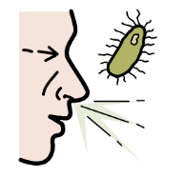  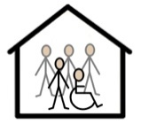  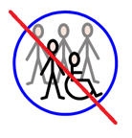 | This report wants to raise the alarm  about the Covid-19 pandemic  and how it affects people with disabilities, including people with intellectual disabilities.  The report talks about the results  of the Covid-19 Disability Rights Monitor.  The Disability Rights Monitor was a survey.  The report is made by 7 disability organisations.  They have a lot of proof from 134 countries  and they also got many stories  from people with disabilities.  This report shows how COVID-19 is  affecting many people with disabilities.  The survey showed that many states have put  the rights to life and health in danger for  people with disabilities.  In some countries, people with disabilities were left behind  and in some countries, States did things that made  the situation worse.  People did not have access to see a doctor  or had to live in overcrowded institutions.  This has caused suffering  and many people were affected  and many people died from COVID-19.  The report also says that countries  failed to include persons with disabilities  in the decision making.
Overview of the report

At the beginning of the COVID-19,
disability rights organisations got a lot of messages
from people with disabilities
because they were worried.

That is why the survey was created
to get information about the situation.
The report also shows how States should take
different measures to protect the rights of people with disabilities.

People with disabilities, governments and
human rights organisations were asked to answer the survey.

Many questions have been asked to them.
The report summarises their replies.

In this report there are 4 topics, which are:

- People with disabilities in institutions
- Community supports
- Impact on children and women with disabilities
and people who are homeless or live in villages
- Healthcare

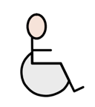 | Part 1 and 2 talk about the reason for the survey and how it was done.  Most replies came from people with disabilities  and their organisations.  The replies came from more than 2,000 people  from 134 countries.  They got little response from the government  and human rights institutions.  That shows that governments are not very inclusive.  Few human rights institutions and independent institutions  that monitor disability rights responded.  This is worrying because  no one is checking regularly what is happening  to people with disabilities.
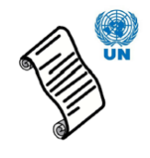  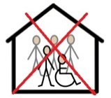 | Part 3 talks about how the situation of people with disabilities  who live in different institutions around the world.  Many people in institutions died  and had no information on how to be safe.  Many people in institutions did not get help  from doctors or nurses.  Institutionalisation violates people’s rights.  The CRPD says that states need to end this.  People have a right to live independently.  Because of what happened, an international group  started working to end institutionalisation.
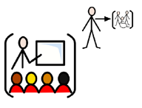  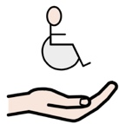 | Part 4 talks about the serious problem in giving support  to people with disabilities during COVID-19.  People did not have access to basic things like:  - Food  - Healthcare  - Assistance  The part also talks about isolation during lockdown  and how it affected the mental health of many people.  The isolation also has increased violence and harassment.  Part 5 talks about what happened to people  who face a lot of discrimination:  - Women and girls with disabilities  - Children with disabilities  - Older people with disabilities  - Homeless people  - People with intellectual disabilities  - People with psychosocial disabilities  - People living in villages  This part says that many children did not get education  during COVID-19 .  Many women with disabilities experienced violence.  People in villages did not get any information  or could not see a doctor.
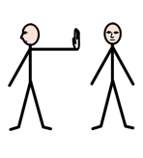 | Part 6 talks about how some States stopped or  denied persons access to treatment,  because of their disability.  This is discrimination.  People also said medicine became more expensive  and that regular health treatments stopped  because of COVID-19.
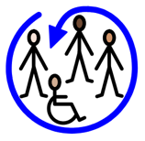  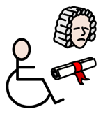  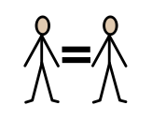  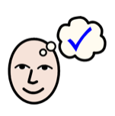 | Conclusions  The survey showed that COVID-19 had  a devastating effect on persons with disabilities.  It also showed that states need to become more inclusive  and respect the rights of persons with disabilities.  Based on the survey, the report gives  11 recommendations for decision makers:  - Protect the rights of persons with disabilities.  - Ensure access to food, medicine and services.  - Ensure access to healthcare and treatment.  Stop discrimination.  - End institutionalisation and  fund community-based projects.  - Equal support for persons with disabilities.  - Involve persons with disabilities  in decisions affecting them.  - Protect persons with disabilities in the response,  and pay special attention to some groups  who are more discriminated,  like girls with disabilities and  people that do not live in big cities.  - Make inclusive education a priority.  - Create accessible information  about COVID-19 and health.  - Train staff to make them aware of disability  and make sure persons with disabilities  have access to justice.

The easy-to-read summary was done by Inclusion Europe.

