Children’s Social Work Statistics 2024-25 – Looked After Children

Headline statistics

Looked after children
- On 31 July 2025, 11,824 children were looked after, compared to 11,780 on 31 July 2024, and down 23% since 2014-15 (15,400).
- The rate of children looked after per 1,000 children slightly increased to 11.8 in 2025 from 11.6 per 1,000 children in 2024. This represents a marginal rise since the previous year, up to which there had been a steady decline since a peak in 2011.
- A total of 2,411 looked after children were looked after at home on 31 July 2025. This is a 5% increase since 2024 (2,298) but down 39% overall since 2014-15. This accounts for 20% of looked after children, consistent with the previous two years but an overall decrease from 25% in 2015.
- On 31 July 2025, the most common placements away from home were kinship care (35%), foster care (28%), and residential accommodation (12%). Since 2022, there has been a higher proportion of looked after children in kinship care than foster care, and kinship care has been the most common placement type.
- During 2024-25, 3,195 children started to be looked after – down 1% since 2023-24 (3,242) and down 24% since 2014-15 (4,198).
- A total of 3,279 children ceased to be looked after during 2024-25 – down 8% since 2023-24 (3,548) and down 25% since 2014-15 (4,371).
- Of those children whose home postcode at the time of becoming looked after was recorded, a little below half (46%) have a home address in one of the 20% most deprived areas in Scotland, whereas 4% were from one of the 20% least deprived areas in Scotland.

Care Leavers

During 2024-25, 958 young people aged 16 years or over ceased to be looked after and were eligible for continuing care. Of these, 38% (367) entered continuing care. This is compared to 32% (327) entering continuing care in 2023-24.

On 31 July 2025, 1,155 young people were in continuing care, 23% of those who were eligible for continuing care at the time of ceasing to be looked after (4,927). This is a similar proportion to the previous year when 22% of those eligible were in continuing care (1,115).

On 31 July 2025, an estimated 9,386 young people were eligible for aftercare services. 4,545 (48% of those eligible, compared to a revised estimate of 51% for the previous year) were receiving aftercare services.

1,951 (54%) of those in aftercare were in education, training or employment - a similar proportion to the previous year when 2,049 young people were in education, training or employment (54%).

Introduction
These statistics include data collected from 32 local authorities in Scotland and cover statistics on: looked after children, young people in continuing care, and young people eligible for aftercare.
These figures relate to the reporting year 01 August 2024 to 31 July 2025. All data used to produce the tables and charts are available in the supporting documents, alongside additional breakdowns. Looked After Children statistics form part of our annual Children’s Social Work data collections. For purposes of presentation, table columns and chart axes refer to these as whole years (e.g., 2025 reflects 01 August 2024-31 July 2025 collection).
This report includes some revisions to figures for the preceding reporting year (2023-24) in line with ongoing data validation improvements. As such, some 2023-24 figures may be different to those previously reported. The percentage of eligible young people receiving aftercare support in 2024 has been revised from 48% in last year's publication to 51% in this report. Please refer to background notes on comparability over time.
This reports includes statistics on the number of unaccompanied asylum seeking (UAS) children who were looked after in Scotland during 2024/25. This is the first time figures for UAS children have been included in these statistics.

An Accredited Official Statistics Publication for Scotland
These statistics are accredited official statistics. The Office for Statistics Regulation has independently reviewed and accredited these statistics as complying with the standards of trustworthiness, quality, and value in the Code of Practice for Statistics. The statistics were accredited in November 2013. Full details can be found in the assessment report.
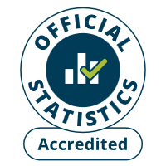
Accredited official statistics are called National Statistics in the Statistics and Registration Service Act 2007.
Scottish Government statistics are regulated by the Office for Statistics Regulation (OSR). OSR sets the standards of trustworthiness, quality and value in the Code of Practice for Statistics that all producers of official statistics should adhere to. Details of the accreditation of these statistics can be found on the OSR website.
More information about Scottish Government statistics is available on the Scottish Government website.

Looked after children
Looked after children are defined as those in the care of their local authority (Children Scotland Act 1995). There are many reasons children may become looked after including: facing abuse or neglect at home; having disabilities that require special care; unaccompanied minors seeking asylum, or illegally trafficked into the UK; or involvement in the youth justice system.
A child may be looked after when they are accommodated under S.25 which may lead to a referral to the Reporter. A referral to the Reporter may lead to an investigation which may lead to a Hearing (or discharge case or voluntary measures). A Hearing may lead to a Compulsory Supervision Order (CSO) or a CSO with secure care authorisation (or no order). A CSO may lead to a child being looked after either away from home or at home. For those looked after away from home, this may lead to a recommendation for permanence away from home. For those with a CSO with secure care authorisation, this may lead to placement in secure care. For those looked after away from home, at home, or in secure care, there will be regular reviews until the case is discharged or the CSO terminated.

Placement types
On 31 July 2025, a total of 11,824 children were looked after. Placement data were recorded for 11,818 children, 20% of whom were placed at home and 80% away from home (Table 1). The number of children looked after has slightly increased since 2024 (11,778) but is still 23% lower than 2015. The majority of children looked after (88%) were placed in community settings. The most common community placements for looked after children were: kinship care (35%), foster care (28%), and at home with parents (20%). A smaller proportion of children (12%) were looked after in residential accommodation settings. Since 2022 kinship care has been the most common community placement, replacing foster care, which had consistently accounted for the largest proportion of placements in previous years.

Table 1 Number and percentage of looked after children by placement type, on 31 July 2015-25 [Note 1], [Note 2], [Note 3], [Note 4], [Note 5]
Placement type | 2015 Number | 2015 Percentage | 2024  Number | 2024 Percentage | 2025  Number | 2025 Percentage
In the community | 13,871 | 90% | 10,454 | 89% | 10,435 | 88%
At home with parents | 3,925 | 25% | 2,298 | 20% | 2,411 | 20%
Kinship Carers: friends/relatives | 4,158 | 27% | 4,067 | 35% | 4,182 | 35%
Foster Carers provided by local authority | 3,889 | 25% | 2,534 | 22% | 2,409 | 20%
Foster Carers purchased by local authority | 1,587 | 10% | 1,117 | 9% | 968 | 8%
Prospective adopters | 264 | 2% | 146 | 1% | 141 | 1%
In other community | 48 | 0% | 292 | 2% | 324 | 3%
Residential accommodation | 1,529 | 10% | 1,324 | 11% | 1,383 | 12%
Local authority home | 564 | 4% | 518 | 4% | 509 | 4%
Voluntary home | 133 | 1% | 75 | 1% | 77 | 1%
Residential school | 402 | 3% | 302 | 3% | 317 | 3%
Secure care accommodation | 79 | 1% | 46 | 0% | 59 | 0%
Crisis care | 18 | 0% | 0 | 0% | 0 | 0%
In other residential [Note 3] | 333 | 2% | 383 | 3% | 421 | 4%
Total | 15,400 | 100% | 11,778 | 100% | 11,818 | 100%
[Note 1] Please note that 2024 figures have been revised since the previous year due to changes to data as part of improved year-on-year reconciliation checks.
[Note 2] Some percentage totals do not exactly equal the sum of their component parts due to the effects of rounding.
[Note 3] The bulk of the ‘other residential’ placements are private/independent residential placements for children with complex needs.
[Note 4] For 2024 the total figure excludes two individuals for which we were missing information on their most recent placement.
[Note 5] For 2025 the total figures excludes six individuals for which we were missing information on their most recent placement.

On 31 July 2025, the rate of looked after children per 1,000 children (0-17 years) was 11.8 – a slight increase from 11.6 in 2024 but lower than the rate (15.1 per 1,000 children) in 2015 (Chart 1). The rate of children looked after at home with their parents declined overall from 3.8 per 1,000 in 2015 to 2.4 per 1,000 in 2025 (up slightly from 2.3 per 1,000 children in 2024). The rate for those placed away from home is also down from 11.0 per 1,000 in 2015 to 9.2 per 1,000 in 2025. More specifically, the rate of children placed with foster carers and prospective adopters decreased from 5.6 per 1,000 in 2015 to 3.5 per 1,000 in 2025, while the rate of children being placed in kinship care and other community placements increased slightly from 4.1 to 4.5 per 1,000 during the same period. For those children being placed in residential care settings, the rate has remained broadly stable, with a slight reduction from 1.5 per 1,000 in 2015 to 1.4 per 1,000 in 2025.
Chart 1 Rate of looked after children per 1,000 children, by placement type, 1988-2025 [Note 1]
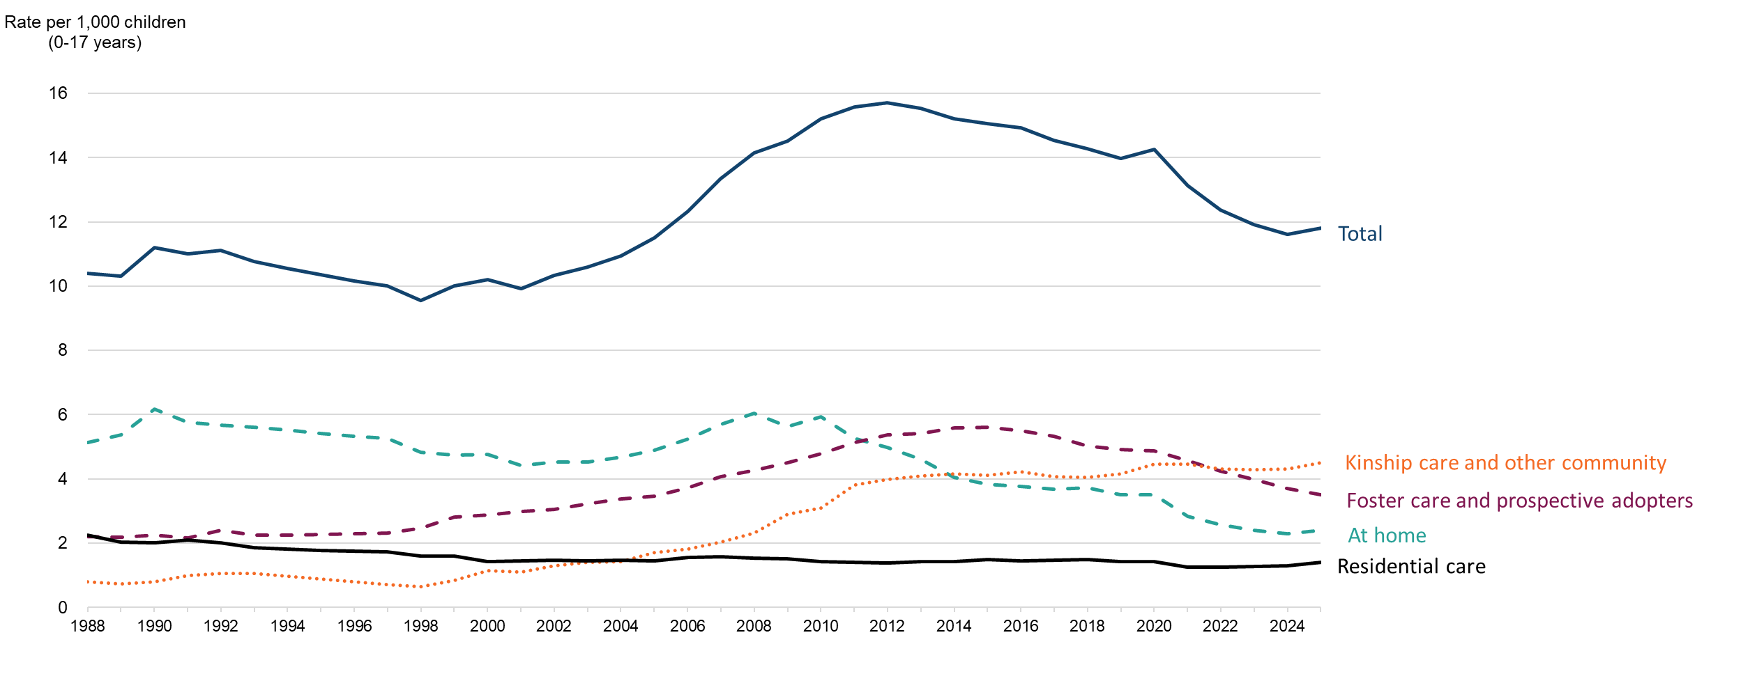
[Note 1] Prior to 2010 figures are as at 31st March. From 2010 onwards figures are as at 31st July.
Care plans
As at 31 July 2025, 91% of looked after children had a current care plan (Table 2). Children looked after at home were as likely to have a current care plan (91%) as those looked after away from home (92%). This is similar to 2023-24 when 92% of children looked after away from home and 91% of those looked after at home had a current care plan. In terms of more specific placement types away from home, those placed with kinship carers (92%), foster carers (93%), and in residential care (92%) were more likely to have a current care plan than those with prospective adopters or in other community placements (80%).

Table 2 Number and percentage of looked after children with and without a current care plan by placement type, on 31 July 2025 [Note 1]
Care plan status | At home | Away from home | Total | With Kinship Carers: friends/relatives | With Foster Carers | With prospective adopters/ other community | In Residential Care
Number with a current care plan | 2,191 | 8,622 | 10,813 | 3,844 | 3,128 | 372 | 1,278
Number without a current care plan | 220 | 785 | 1,005 | 338 | 249 | 93 | 105
Total | 2,411 | 9,407 | 11,818 | 4,182 | 3,377 | 465 | 1,383
Percentage with a current care plan | 91% | 92% | 91% | 92% | 93% | 80% | 92%
Percentage without a current care plan | 9% | 8% | 9% | 8% | 7% | 20% | 8%
[Note 1] Some children without a current care plan may have one in progress on this date; local recording may differ with regard to when a care plan is recorded as being in place

Age and sex
Of the 11,824 children who were looked after as at 31 July 2025, 5,398 (46%) were female and 6,415 (54%) were male (Table 3). The proportion of males being looked after is higher amongst the older age groups. For example, 64% of looked after 17 year olds are male and 70% of those 18 years or older are male.
Table 3 Percentage of children looked after by sex and age, 31 July 2025 [Note 1]
Age | Female Number | Female Percentage | Male Number | Male Percentage | All
Under 1 years old | 142 | 45% | 177 | 55% | 319
1 years old | 215 | 51% | 207 | 49% | 422
2 years old | 222 | 49% | 233 | 51% | 455
3 years old | 183 | 44% | 231 | 56% | 414
4 years old | 234 | 52% | 216 | 48% | 450
5 years old | 233 | 49% | 246 | 51% | 479
6 years old | 239 | 48% | 257 | 52% | 496
7 years old | 259 | 48% | 277 | 52% | 537
8 years old | 279 | 48% | 298 | 52% | 578
9 years old | 293 | 48% | 320 | 52% | 613
10 years old | 295 | 47% | 332 | 53% | 627
11 years old | 300 | 44% | 379 | 56% | 679
12 years old | 359 | 46% | 420 | 54% | 779
13 years old | 399 | 49% | 414 | 51% | 813
14 years old | 426 | 43% | 553 | 56% | 981
15 years old | 498 | 47% | 565 | 53% | 1,064
16 years old | 438 | 43% | 568 | 56% | 1,009
17 years old | 337 | 36% | 608 | 64% | 946
18+ years old | 47 | 29% | 114 | 70% | 163
All | 5,398 | 46% | 6,415 | 54% | 11,824
[Note 1] Where Male or Female sex is not specified, children are included in the "All" sex category.

Area deprivation
Of those whose home postcode at the time of becoming looked after was recorded (67% of all looked after children), almost half (46%) come from one of the 20% most deprived areas in Scotland. This is followed by just over a quarter (26%) from the 20-40% most deprived areas. 4% of looked after children were from one of the 20% least deprived areas in Scotland. (Table 4). In 2023-24, 54% of children whose home postcode was recorded came from one of the 20% most deprived areas in Scotland, followed by 24% from the 20-40% most deprived areas.

The difference between the proportion of looked after children whose home postcode is in the most deprived areas compared to in the least deprived areas is more pronounced among children in placements within the community (except for ‘other community’ placements) than among those in residential accommodation. Among children placed within the community, 47% come from one of the 20% most deprived areas in Scotland, while only 4% come from the one of the 20% least deprived areas. This is compared to those placed in residential accommodation, of whom 37% come from one of the 20% most deprived areas and 7% come from the 20% least deprived areas.
Table 4 Percentage of children looked after by home Scottish Index of Multiple Deprivation (SIMD) Quintile, placement type, 31 July 2025 [Note 1]
Placement type subcategory | SIMD 1 (20% most deprived areas) | SIMD 2 | SIMD 3 | SIMD 4 | SIMD 5 (20% least deprived areas)
At home with parents | 49% | 28% | 12% | 8% | 2%
With friends/relatives | 50% | 27% | 12% | 9% | 3%
With foster carers | 45% | 24% | 15% | 10% | 5%
With prospective adopters | 44% | 29% | 19% | 8% | 0%
In other community | 27% | 25% | 15% | 10% | 22%
Total in the community | 47% | 26% | 13% | 9% | 4%
In Local Authority home | 39% | 28% | 17% | 11% | 5%
In voluntary home | 21% | 34% | 15% | 21% | 9%
In residential school | 36% | 18% | 18% | 18% | 10%
In secure accommodation | 46% | 22% | 12% | 15% | 5%
Other residential | 37% | 26% | 17% | 15% | 5%
Total in residential accommodation | 37% | 25% | 17% | 15% | 7%
Total looked after children | 46% | 26% | 14% | 10% | 4%
[Note 1] Percentage totals exclude those whom we do not have SIMD information.

Children starting and ceasing to be looked after
During 2024-25, 3,195 children started to be looked after – a rate of 3.1 per 1,000 children (0-17 years; Chart 2). A total of 3,279 children ceased to be looked after – a rate of 3.2 per 1,000 children. Compared to 2023-24, this reflects both a slight decrease in the rate of children starting to be looked after (from 3.2 per 1,000) and a slight decrease in the rate of children ceasing to be looked after (from 3.5 per 1,000). There has been an overall reduction in both the rate of children starting to be looked after (from 4.1 per 1,000) and ceasing to be looked after (from 4.3 per 1,000) since 2014-15.
Chart 2 Rate per 1,000 children starting and ceasing to be looked after during the year, 2003-2025 [Note 1]
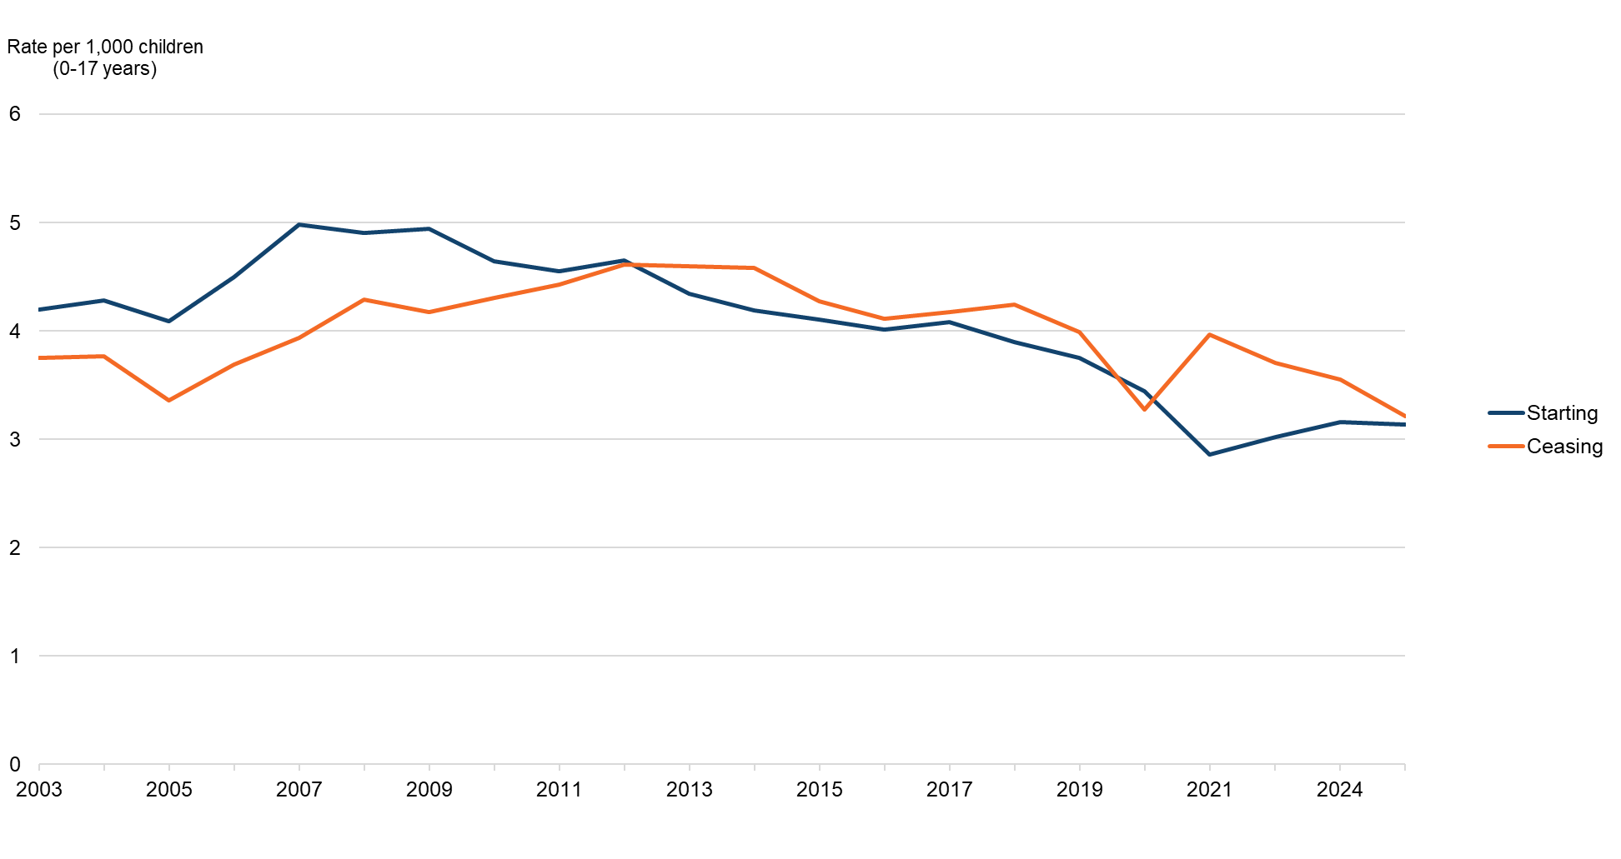
[Note 1] A child may start to be looked after more than once in a year and so may be counted more than once.

Children starting to be looked after
During 2024-25, 3,195 children started to be looked after (Table 5). The number of children starting to be looked after has decreased by 1% since 2023-24 and by 24% since 2014-15. In 2024–25, 56% of children starting to be looked after were male, while 44% were female. This proportion of male children was slightly lower than in 2023–24 (57%) but higher than in 2014–15 (53%). Over the past decade, the proportion of children starting to be looked after who were under 4 years of age has declined, from 38% in 2014-15 to 32% in 2023-24 and 2024-25. Meanwhile the proportion of those starting to be looked after who were 16-17 years of age has been on an overall upward trend during the same period, rising from 1% in 2014–15 to 13% in 2023-24, though this has declined slightly to 11% in 2024-25.
Table 5 Number and percentage of children starting to be looked after during the year by sex and age of child 2015-2025 [Note 1], [Note 2], [Note 3], [Note 4], [Note 5]
Category | Subcategory | 2015  Number | 2015  Percentage | 2024  Number | 2024  Percentage | 2025  Number | 2025  Percentage
Sex | Male | 2,238 | 53% | 1,833 | 57% | 1,788 | 56%
Sex | Female | 1,960 | 47% | 1,405 | 43% | 1,405 | 44%
Age | Under 1 years | 668 | 16% | 458 | 14% | 459 | 14%
Age | 1-4 years | 933 | 22% | 567 | 17% | 557 | 17%
Age | 5-11 years | 1,305 | 31% | 918 | 28% | 975 | 31%
Age | 12-15 years | 1,232 | 29% | 890 | 27% | 861 | 27%
Age | 16-17 years | 58 | 1% | 406 | 13% | 340 | 11%
Age | 18+ years | 2 | 0% | 3 | 0% | 3 | 0%
Age | Not known | 0 | 0% | 0 | 0% | 0 | 0%
Total | Total | 4,198 | 100% | 3,242 | 100% | 3,195 | 100%
[Note 1] A child may start to be looked after more than once in a year and so may be counted more than once.
[Note 2] Table excludes planned series of short-term placements.
[Note 3] Please note that 2024 figures have been revised since the previous year due to changes to data as part of improved year-on-year reconciliation checks.
[Note 4] Some totals do not exactly equal the sum of their component parts due to the effects of rounding.
[Note 5] For a very small number of children Male or Female sex was not specified, they are included in the "Age" category.

Children ceasing to be looked after
During 2024-25, 3,279 children ceased to be looked after (Table 6). The number of children ceasing to be looked after has decreased by 8% since 2023-24 (3,548) and by 25% since 2014-15 (4,371). Compared with 2014-15, the proportions of children ceasing to be looked after whose episodes of care lasted for periods less than 5 years have all decreased since 2014-15. Meanwhile, the proportion of children with long care episodes of 5 years and over increased overall since 2014–15, rising from 18% to 25% in 2024–25. However, this represents a decrease from a peak of 28% in 2023–24.

Table 6 Number and percentage of children ceasing to be looked after during the year by episode duration 2015-2025 [Note 1], [Note 2], [Note 3], [Note 4]
Length of time looked after | 2015 Number | 2015 Percentage | 2024 Number | 2024 Percentage | 2025 Number | 2025 Percentage
Under 6 weeks | 293 | 7% | 180 | 5% | 179 | 5%
6 weeks to under 6 months | 371 | 8% | 293 | 8% | 270 | 8%
6 months to under 1 year | 578 | 13% | 435 | 12% | 369 | 11%
1 year to under 3 years | 1,620 | 37% | 1,074 | 30% | 1,186 | 36%
3 years to under 5 years | 740 | 17% | 581 | 16% | 464 | 14%
5 years and over | 769 | 18% | 985 | 28% | 811 | 25%
Total | 4,371 | 100% | 3,548 | 100% | 3,279 | 100%

[Note 1] A child may cease to be looked after more than once in a year and so may be counted more than once.
[Note 2] Table excludes children on a planned series of short term placements.
[Note 3] Please note 2024 figures have been revised since the previous year due to changes to data as part of improved year-on-year reconciliation checks.
[Note 4] Some totals do not exactly equal the sum of their component parts due to the effects of rounding.

Destination of children ceasing to be looked after
Of the 3,279 children who ceased to be looked after during 2024-25, 43% had a recorded destination of at home with their biological parents (similar to the 44% the year before) (Table 7). This is the most common destination, but this figure is a considerable reduction when compared to that observed in 2014-15, when 61% of children ceasing to be looked after had a recorded destination of at home with their biological parents. In 2024-25, 12% of children had a recorded destination of kinship care with friends or relatives, down 2 percentage points from the previous year (14%), and compared to 17% in 2014-15. 12% of children who ceased to be looked after during 2024-25 had a recorded destination of ‘Other’ (including residential care, homeless, in custody and other destinations), compared to 5% in 2014-15.
Table 7 Number and percentage of children ceasing to be looked after during the year by destination accommodation 2015-2025 [Note 1], [Note 2], [Note 3], [Note 4], [Note 5], [Note 7], [Note 8]
Destination accommodation | 2015  Number | 2015  Percentage |  | 2024 Number |  | 2024  Percentage |  | 2025 Number |  | 2025 Percentage
At home with parents | 2,682 | 61% | 1573 |  | 44% |  | 1402 |  | 43%
Kinship Carers: friends/relatives | 745 | 17% | 491 |  | 14% |  | 404 |  | 12%
Kinship Care Order | - | 0% | 161 |  | 5% |  | 114 |  | 3%
Former Foster Carers | 80 | 2% | 90 |  | 3% |  | 33 |  | 1%
Continuing Care | - | 0% | 334 |  | 9% |  | 400 |  | 12%
Adopted | 303 | 7% | 194 |  | 5% |  | 153 |  | 5%
Supported accommodation / own tenancy | 295 | 7% | 308 |  | 9% |  | 380 |  | 12%
Other [Note 6] | 219 | 5% | 361 |  | 10% |  | 385 |  | 12%
Not known | 47 | 1% | 32 |  | 1% |  | 8 |  | 0%
Total | 4,371 | 100% | 3,544 |  | 100% |  | 3,279 |  | 100%
[Note 1] A child may cease to be looked after more than once in a year and so may be counted more than once.
[Note 2] Table excludes planned series of short-term placements.
[Note 3] Please note that 2024 figures have been revised since the previous year due to ongoing validation work.
[Note 4] Some totals do not exactly equal the sum of their component parts due to the effects of rounding.
[Note 5] Cells shown as " - " relate to 'Continuing Care' and 'Kinship Care Order' categories which were added in 2018. Prior to this, children in continuing care were mainly recorded in the former foster carers category, and those with Kinship Care Order were mainly recorded in the friends/relatives category.
[Note 6] 'Other' includes residential care, homeless, in custody and other destinations.
[Note 7] Figure for 2025 includes two individuals under the age of 16 whose destination accommodation was recorded as Continuing Care.
[Note 8] Figure for 2025 includes thirty-one individuals whose destination accommodation was recorded as Continuing Care but whose final placement did not match eligibility criteria for continuing care (i.e. kinship, foster or residential).

Pathway plans for children ceasing to be looked after
During 2024-25, 76% of children who were 16 years or over on the date they ceased to be looked after had a pathway plan upon discharge and 57% had a pathway coordinator (Table 8). This is compared to 74% with a pathway plan and 56% with a pathway coordinator in 2023-24. Children whose final placement was at home were less likely to have a pathway plan (67%) than those who had been placed away from home (79%). Those whose final placement was away from home were more likely to have a pathway coordinator (59%) than those whose final placement was at home (49%).
Table 8 Pathway plans and co-ordinators of children who were 16 years old or over on the date they ceased to be looked after during 2024-25 [Note 1], [Note 2]
Pathway plan status | At home  Number | Away from home  Number | Total  Number | At home  Percentage | Away from home  Percentage | Total  Percentage
With a pathway plan on date of discharge | 181 | 939 | 1,120 | 67% | 79% | 76%
Without a pathway plan on date of discharge | 91 | 255 | 346 | 33% | 21% | 24%
With pathway co-ordinator | 132 | 711 | 843 | 49% | 59% | 57%
Without pathway co-ordinator | 140 | 484 | 624 | 51% | 41% | 43%
Total | 272 | 1,195 | 1,467 | 100% | 100% | 100%
Table 8 Continued
Pathway plan status | With Kinship Carers: friends/relatives  Number | With Foster Carers  Number | With prospective adopters/ other community  Number | In Residential Care  Number
With a pathway plan on date of discharge | 262 | 246 | 175 | 256
Without a pathway plan on date of discharge | 79 | 45 | 62 | 69
With pathway co-ordinator | 199 | 175 | 136 | 201
Without pathway co-ordinator | 142 | 116 | 101 | 125
Total | 341 | 291 | 237 | 326
[Note 1] Figures include all episodes of ceasing to be looked after beyond 16 years of age (i.e. a child may be counted more than once).
[Note 2] It may be the case that some children who do not have a relevant pathway plan/coordinator may be receiving similar support from adult services instead.

Unaccompanied asylum seeking children
A total of 680 unaccompanied asylum seeking children were recorded as looked after during the year for 2024-25, in data returned by 29 local authorities (see Table 9, Note 2). On 31 July 2025, 380 unaccompanied asylum seeking children were looked after in Scotland (Table 9). Over three quarters of these children (78%) were placed in community settings. The most common community placements were ‘other community’ (67%) and foster care (10%), with a further 2% in kinship care. 22% of unaccompanied asylum seeking children were looked after in residential accommodation settings, including 13% in other residential and 8% in local authority homes.
Table 9 Number and percentage of Unaccompanied Asylum Seeking Children looked after by placement type, 31 July 2025 [Note 1], [Note 2]
Placement type | 2025 Number | 2025 Percentage
In the community | 296 | 78%
At home with parents | - | 0%
Kinship Carers: friends/relatives | 6 | 2%
Foster Carers provided by local authority | 23 | 6%
Foster Carers purchased by local authority | 14 | 4%
Prospective adopters | - | 0%
In other community | 253 | 67%
Residential accommodation | 83 | 22%
Local authority home | 29 | 8%
Voluntary home | 3 | 1%
Residential school | - | 0%
Secure care accommodation | 1 | 0%
Crisis care | - | 0%
In other residential [Note 1] | 50 | 13%
Total | 380 | 100%
[Note 1] The bulk of ‘other residential’ placements are private/independent residential placements.
[Note 2] Figures include data collected from 29 local authorities. Unaccompanied asylum seeking children data were not available for Fife, North Ayrshire and Midlothian.
Of the 380 unaccompanied asylum seeking children who were looked after on 31 July 2025, 12% were female and 88% were male, and all were aged 14 years or older (Table 10). 17 year olds accounted for 60% of looked after unaccompanied asylum seeking children, with a further 22% being 16 years old and 13% being 18 years old.
Table 10 Number of children looked after who are Unaccompanied Asylum Seeking Children by sex and age, 31 July 2025 [Note 1], [Note 2]
Age | Female Number | Female Percentage | Male Number | Male Percentage | All | All  Percentage
14 years old | 0 | 0% | 2 | 1% | 2 | 1%
15 years old | 1 | 2% | 15 | 4% | 16 | 4%
16 years old | 16 | 36% | 68 | 20% | 84 | 22%
17 years old | 24 | 53% | 205 | 61% | 229 | 60%
18+ years old | 4 | 9% | 44 | 13% | 49 | 13%
All | 45 | 12% | 334 | 88% | 380 | 100%
[Note 1] Where Male or Female sex is not specified, children are included in the “All” sex category.
[Note 2] Figures include data collected from 29 local authorities. Unaccompanied asylum seeking children data were not available for Fife, North Ayrshire and Midlothian.
Of the 680 unaccompanied asylum seeking children looked after during the year, 273 ceased to be looked after during 2024-25. Of these almost two thirds had a destination of supported accommodation/own tenancy, with a further 14% in continuing care (Table 11). Only 3% had a destination accommodation of kinship carer and 1% with foster carers.
Table 11 Number and percentage of unaccompanied asylum seeking children ceasing to be looked after during the year by destination accommodation [Note 1], [Note 2]
Destination accommodation | 2025 Number | 2025 Percentage
At home with parents | 1 | 0%
Kinship Carers: friends/relatives | 8 | 3%
Former Foster Carers | 4 | 1%
Continuing Care | 37 | 14%
Supported accommodation / own tenancy | 176 | 64%
Other [Note 1] | 46 | 17%
Total | 273 | 100%
[Note 1] 'Other' category includes residential care, homeless, in custody
[Note 2] Figures include data collected from 29 local authorities. Unaccompanied asylum seeking children data were not available for Fife, North Ayrshire and Midlothian.

Cross UK comparisons
On 31 March 2025, Scotland’s rate of children looked after was 116 per 10,000, a reduction from 118 per 10,000 in 2024 and the lowest level recorded since 2005 (Chart 3). In 2025, Scotland’s rate remained higher than that of England (67 per 10,000) and Northern Ireland (96 per 10,000), and was equal to that of Wales (116 per 10,000). However, unlike the other UK nations, Scotland has seen a sustained decline in the rate of children looked after over the past decade. It should be noted that child care systems operate under different legislative frameworks across the UK, and caution is therefore required when making direct comparisons between countries.

Chart 3 Cross UK comparisons of rate per 10,000 looked after children 31 March 2015-2025 [Note 1], [Note 2], [Note 3], [Note 4], [Note 5]
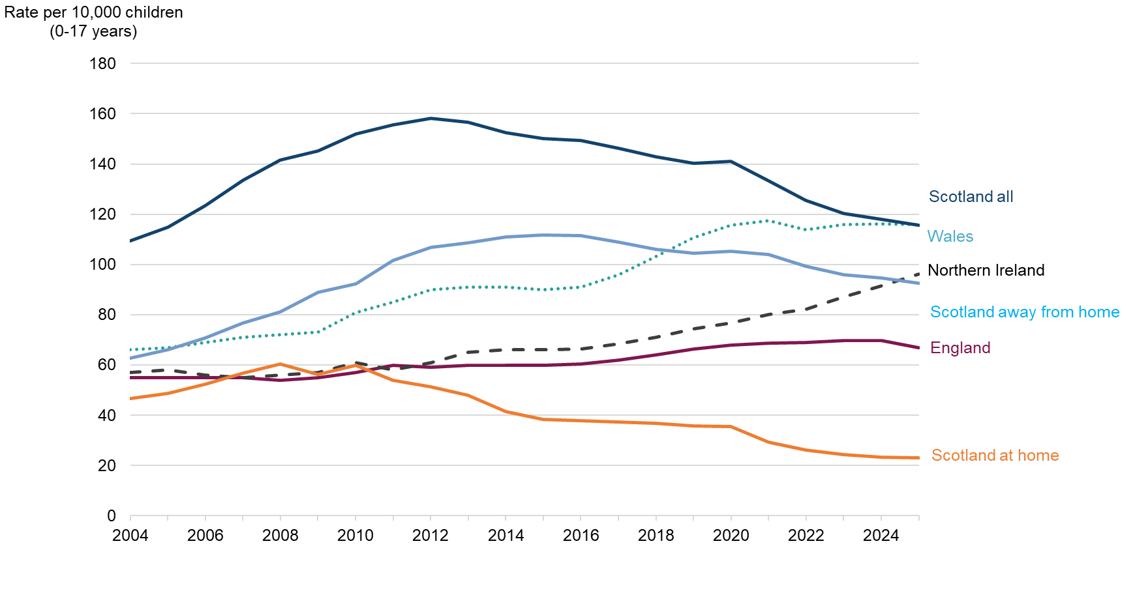
[Note 1] Scotland data is on 31st March for comparability purposes with other UK countries.
[Note 2] It should be noted that UK nations operate under different legislative frameworks, and as such are not directly comparable.
[Note 3] England data source: Children Looked After in England including Adoption, Reporting year 2025
[Note 4] Wales data source: Children looked after (gov.wales)
[Note 5] Northern Ireland Source: Children's social care statistics for Northern Ireland 2024/25

Care Leavers

Continuing Care

Continuing care is the continued provision of the accommodation and other assistance, immediately before the young person ceases to be looked after, being provided by local authorities, under section 67 of The Children and Young People (Scotland) Act 2014, which inserted a new section 26A in the Children (Scotland) 1995 Act. Please see background notes for eligibility criteria.

Young people ceasing to be looked after during the year and entering continuing care
A total of 958 young people aged 16 years or over ceased to be looked after in a placement that falls under eligibility criteria for continuing care (i.e., kinship care, foster care, or residential accommodation). Of these, 367 or 38% entered continuing care after ceasing to be looked after (Table 12). This compares to 327 (32%) entering continuing care after ceasing to be looked after in 2024. 52% of those in foster care who ceased to be looked after aged 16 years or older entered continuing care. This compares to 34% of those in residential care and 31% of those in kinship care.

Table 12 Number of young people aged 16 years old or over ceasing to be looked after with a destination of Continuing Care by placement type [Note 1], [Note 2], [Note 3]

Ceasing to be looked after category | Kinship care | Foster care | Residential accommodation | Total
Total number ceasing to be looked after | 341 | 291 | 326 | 958
Number entering Continuing Care after ceasing to be looked after | 106 | 151 | 110 | 367
Proportion entering Continuing Care of all young people ceasing to be looked after | 31% | 52% | 34% | 38%

[Note 1] Kinship placements include placements where young people are with family/relatives.
[Note 2] Foster placements include placements where young people are with foster carers provided by Local Authority or with foster carers purchased by Local Authority.
[Note 3] Residential placements include placements in Local Authority home, in voluntary home, residential school, secure care, and other residential.

During 2024-25, the proportion of young people ceasing to be looked after with a destination of continuing care has increased from 9% in 2023-24 to 11% in 2024-25 (Table 13). Of all young people ceasing to be looked after during the year with a destination of continuing care, the greatest proportion were in foster care (41%), followed by residential accommodation (30%) and kinship care (29%). Almost two thirds of young people ceasing to be looked after during the year with a destination of continuing care were aged 18 years (62%).

Table 13 Number and percentage of young people ceasing to be looked after during the year with a destination of continuing care by age and placement type, 2021-25 [Note 1], [Note 2], [Note 3], [Note 4]
Placement Type / Age | 2021  Number | 2021  Percentage | 2022  Number | 2022  Percentage | 2023  Number | 2023  Percentage | 2024 Number | 2024  Percentage | 2025  Number | 2025  Percentage
Kinship care | 37 | 14% | 38 | 14% | 64 | 21% | 71 | 22% | 106 | 29%
Foster care | 132 | 51% | 135 | 50% | 134 | 44% | 171 | 52% | 151 | 41%
Residential accommodation | 88 | 34% | 95 | 35% | 104 | 34% | 84 | 26% | 110 | 30%
16 years at episode end | 42 | 16% | 35 | 13% | 51 | 17% | 50 | 15% | 37 | 10%
17 years at episode end | 110 | 43% | 151 | 56% | 227 | 75% | 168 | 52% | 91 | 25%
18 years at episode end | 105 | 41% | 80 | 30% | 21 | 7% | 104 | 32% | 227 | 62%
19-21 years at episode end | 0 | 0% | 2 | 1% | 3 | 1% | 3 | 1% | 12 | 3%
22+ years at episode end |  |  |  |  | 0 | 0% | 1 | 0% | 0 | 0%
Total | 257 | 100% | 268 | 100% | 302 | 100% | 326 | 100% | 367 | 100%
[Note 1] Kinship placements include placements where young people are with family/relatives.
[Note 2] Foster placements include placements where young people are with foster carers provided by Local Authority or with foster carers purchased by Local Authority.
[Note 3] Residential placements include placements in Local Authority home, in voluntary home, residential school, secure care and other residential.
[Note 4] The total excludes those who have a destination of Continuing Care but whose final placement did not match eligibility criteria for continuing care (i.e. kinship, foster or residential).

Young people in continuing care as at 31 July
On 31 July 2025, 1,155 young people were in continuing care (Table 14). This is an increase of 4% on the figure from 2024 (1,115). 56% of young people in continuing care were aged 19-21 years old, followed by 35% aged 18, 7% aged 17 years old and a smaller percentage (2%) who were 16 years old. On 31 July 2025, 4,927 young people were eligible for continuing care, of whom 1,150 were receiving continuing care (23%). This is a slight increase in proportion of eligible young people in receipt of continuing care compared to the previous year where 1,115 (22%) of the 4,985 were receiving continuing care.

Table 14 Number and percentage of young people receiving continuing care by age on 31 July [Note 2]
Age | 2022 Number | 2022  Percentage | 2023  Number | 2023  Percentage | 2024  Number | 2024  Percentage | 2025  Number | 2025  Percentage | Percentage change since previous year
16 years | 17 | 2% | 18 | 2% | 31 | 3% | 22 | 2% | -29%
17 years | 47 | 7% | 67 | 9% | 77 | 7% | 78 | 7% | 1%
18 years | 251 | 36% | 258 | 33% | 420 | 38% | 409 | 35% | -3%
19-21 years | 369 | 53% | 433 | 56% | 586 | 53% | 643 | 56% | 10%
22+ years [Note 1] | 12 | 2% | 1 | 0% | 1 | 0% | 3 | 0% | 200%
Total | 696 | 100% | 777 | 100% | 1,115 | 100% | 1,155 | 100% | 4%
[Note 1] Young people aged 22+ are not technically eligible for Continuing Care but there may be some special cases.
[Note 2] Due to a change in the data collection, data from 2024 onwards may not be directly comparable to previous years.

On 31 July 2025, the rate per 1,000 young people (16-21 years) receiving Continuing Care was 3.1, a slight increase from 2024 (3.0) (see Additional Table 14).

Aftercare
Aftercare refers to the advice, guidance and assistance provided to care leavers under section 29 of the Children and Young People (Scotland) 1995 Act. Please see background notes for eligibility criteria.

Eligibility for aftercare
On 31 July 2025, 4,545 were receiving aftercare services – a 2% increase from 4,459 receiving services in 2024. 9,386 young people were eligible for aftercare services – a 8% increase from a revised estimate of 8,680 eligible in 2024 (Table 15). Almost half of those eligible (48%) were receiving aftercare services compared to a revised estimate of 51% in 2024.

Table 15 Number and percentage of young people eligible for and receiving aftercare services by age, 31 July 2025 [Note 1]
Status | 16 | 17 | 18 | 19-21 | 22+ | Total | Percentage change since previous year
Number in receipt of aftercare | 88 | 269 | 620 | 1,816 | 1,752 | 4,545 | 2%
Number not in receipt of aftercare | 92 | 248 | 422 | 1,537 | 2,542 | 4,841 | 15%
Total eligible for aftercare[1] | 180 | 517 | 1,042 | 3,353 | 4,294 | 9,386 | 8%
Percentage in receipt of aftercare | 49% | 52% | 60% | 54% | 41% | 48%
Percentage not in receipt of aftercare | 51% | 48% | 40% | 46% | 59% | 52%
Total eligible for aftercare | 100% | 100% | 100% | 100% | 100% | 100%

[Note 1] The number eligible for aftercare in 2024-25 is estimated based on data received on: number of eligible needs assessments in 2024-25, where an eligible need was identified; number eligible for aftercare recorded in 2023-24, where the young person is still within the age criteria for aftercare in 2024-25; number of care leavers in 2024-25 within the compulsory age criteria for aftercare, not looked after or in continuing care as at 31 July 2025; and young people otherwise included in the Care Leavers return as eligible for aftercare. Young people are counted only once within this estimate, where they meet more than one of these eligibility criteria.

Chart 4 Number of young people eligible and receiving aftercare services on 31 July 2009-2025 [Note 1]
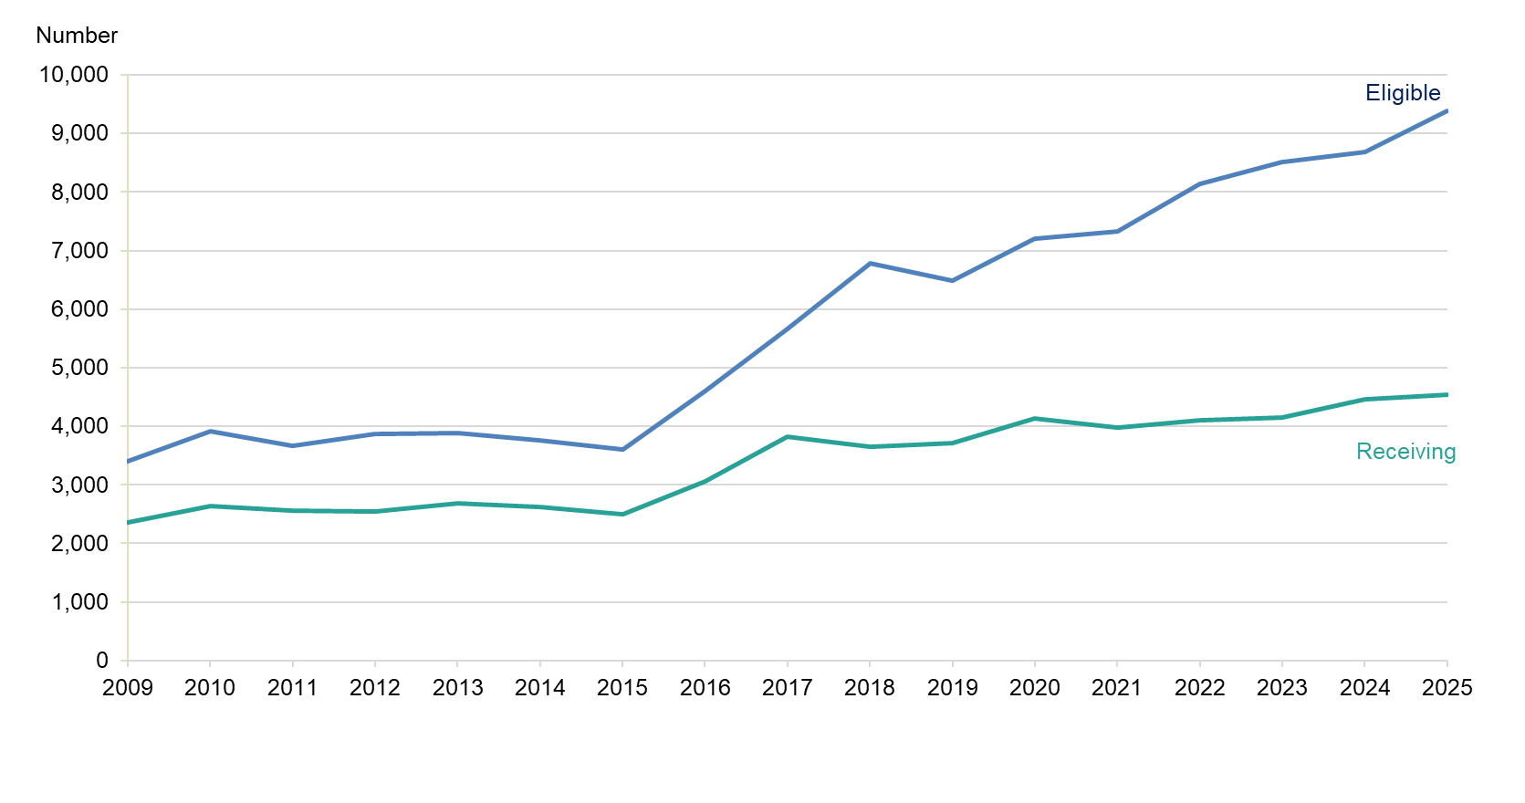
[Note 1] The number eligible for aftercare in 2024-25 is estimated based on data received on: number of eligible needs assessments in 2024-25, where an eligible need was identified; number eligible for aftercare recorded in 2023-24, where the young person is still within the age criteria for aftercare in 2024-25; number of care leavers in 2024-25 within the compulsory age criteria for aftercare, not looked after or in continuing care as at 31 July 2025; and young people otherwise included in the Care Leavers return as eligible for aftercare. Young people are counted only once within this estimate, where they meet more than one of these eligibility criteria.

Aftercare and economic activity
Of the 3,634 young people in aftercare from whom economic status is known, 1,951 of them were in education, training or employment (Table 16). This is 54% of young people in aftercare where their economic status is known. Of these, 401 were in higher education, 785 were in education other than higher education and 765 were in training or employment. 1,683 young people were not in education, training or employment. This is a similar proportion to 2024, where 2,049 young people were in education, training or employment (54%).

Table 16 Number of young people receiving aftercare services by sex and economic activity, 31 July 2025 [Note 1], [Note 2]
Economic activity category | Economic activity | Female | Male | Total
In education, training or employment | In higher education | 203 | 195 | 401
In education, training or employment | In education other than HE | 280 | 503 | 785
In education, training or employment | In training or employment | 317 | 447 | 765
In education, training or employment | Total | 800 | 1,145 | 1,951
Not in education, training or employment | Due to short term illness | 16 | 23 | 39
Not in education, training or employment | Due to long term illness or disability | 103 | 149 | 252
Not in education, training or employment | Due to looking after family | 100 | 13 | 113
Not in education, training or employment | Due to other circumstances | 454 | 822 | 1,279
Not in education, training or employment | Total | 673 | 1,007 | 1,683
Not known | Not known | 304 | 607 | 911
Total | n/a | 1,777 | 2,759 | 4,545
Percentage | n/a | 39% | 61% | 100%
Scotland Percentage [Note 1] | n/a | 50% | 50% | 100%
Percentage in education, training or employment as a percentage of all young people receiving aftercare ("Total") |  | 45% | 42% | 43%
Percentage in education, training or employment as a percentage where information on economic activity is available ("Total" excluding "Not Known") |  | 54% | 53% | 54%
[Note 1] Scotland percentages refer to males and females aged 16 to 26 based on mid-2024 NRS population estimates in line with eligibility criteria for aftercare support.
[Note 2] Where Male or Female sex is not specified, young people are included in the “Total” column.

Trends in other children’s social work data
The number of children referred to the Children’s Reporter as at 31 March decreased annually over the last decade, with the exception of a slight increase in 2023, by 38% from 15,858 in 2015 to 9,789 in 2025. The decrease of the past decade is the result of falls in both the number of offence (down 15% since 2015) and non-offence referrals (down by 45% since 2015). Offence referrals now account for 15% of all referrals. The fall in referrals to the Reporter is likely to be due to pre-referral screening across many areas of the country. This has led to a reduction in referrals received by the Reporter where compulsory measures are not deemed necessary, and a proportionate increase in referrals, where deemed necessary.

Chart 5 Number of children referred to the Children’s Reporter and numbers looked after/on child protection register, 2004-2025 [Note 1]
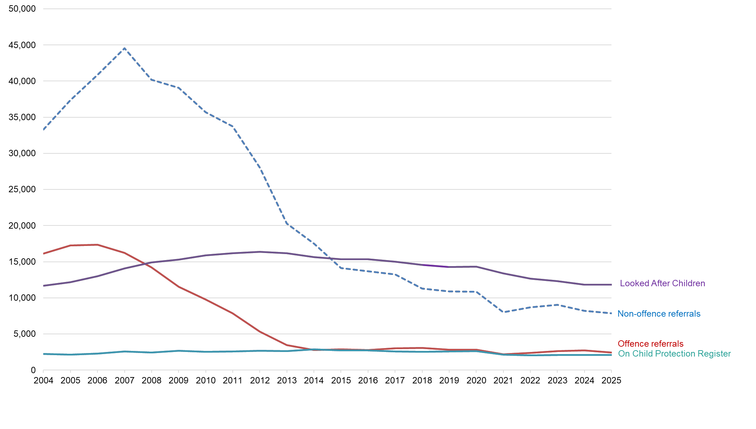
[Note 1] Data source for referrals to the Children’s Reporter is from the Scottish Children’s Reporter Administration website: SCRA.

Background notes

Glossary

Referral to the Reporter
Children are referred to the Children's Reporter if it is considered that they may need compulsory legal measures of protection, guidance, treatment or control. Most referrals come from partner agencies, such as the police, social work, and education. Additionally, parents, family members, carers or members of the public can make a referral.

Investigations and Children’s Hearings
The Reporter will investigate the referral and decide whether to convene a Children's Hearing or discharge the case. The Children’s Hearing is a legal tribunal which considers and makes decisions on the welfare of the child or young person, taking into account their circumstances including any offending behaviour. The Hearing will decide what's in the best interest of the child and whether compulsory measures of supervision are necessary and, if so, which ones.

Community setting placements

At home with parents
A child becomes looked after at home when the Children's Hearings system imposes a Supervision Requirement with no condition of residence. A child looked after at home continues to live at their normal residence (usually the family home) but receives regular visits from social workers to ensure that the objectives of the home Supervision Order are being met. There are two main instances in which this happens:
- as a starting point for planned intervention, where the balance of risk indicates that it is not essential to remove the child from the care of their parents, but that the situation must be monitored;
- where children are returning home after being looked after away from home, where some risks still remain and home supervision aims to help reunite the family.

Kinship care
Kinship care is when a child is looked after by their extended family or close friends if they cannot remain with their birth parents. Under the Looked After Children (Scotland) Regulations 2009, a kinship carer is defined as "a person who is related to the child (through blood, marriage or civil partnership) or a person with whom the child has a pre-existing relationship". Kinship care includes both (1) looked after children who have been placed with kinship carers by the local authority; and (2) non-looked after children who live in an informal kinship care arrangement (these children may be subject to an order under Section 11 of the Children (Scotland) Act 1995 or may be living in a completely private arrangement with extended family, with no local authority involvement).
A Kinship Care Order is a court order that confers all or part of parental responsibilities and rights to a friend or relative of the child and can be a trigger for receipt of kinship care assistance. In such circumstances, the child would no longer be looked after.

Foster Care
When a child cannot be cared for by their birth parents, or by kinship carers, they can be cared for by an approved foster family. Any adult can apply to become a foster carer by sending an application to their local authority or to a voluntary or independent provider registered with the Care Inspectorate. Foster care can be a temporary arrangement that can end when a child returns to their birth parents, or is adopted. Other placements can be long term if this is in the best interests of the child. Foster cares can be (1) provided by local authority, or (2) purchased by a local authority.

With prospective adopters
This refers to children living with their prospective adopters, during the formal legal process in which all the rights and responsibilities relating to a child are transferred to the adoptive parents.

In other community
This could be any other placement in the community, such as, for example, supported accommodation.

Residential care placements
Placements in residential accommodation settings offer children, usually of secondary school age, a safe place to live together with other children away from home. They provide accommodation, support and, in some cases, education. Residential care settings include local authority and voluntary homes/hostels, residential schools, secure care accommodation, crisis care and other types of residential settings.

Care plan
When children become looked after, a care plan is produced by the local authority. The care plan includes detailed information about the child’s care, education, and health needs, as well as the responsibilities of the local authority, the parents, and the child. A care plan is considered ‘current’ if it has been produced or reviewed in the past 12 months.

Pathway plans
Local authorities have a duty to provide advice, guidance and assistance for young people who at the point of leaving care have reached 16 years of age. This is referred to as ‘aftercare services’. Local authorities are required to carry out a pathway assessment for aftercare services for all currently looked after young people who are over the age of sixteen and every 'compulsorily supported person' (a care leaver who has not yet reached their nineteenth birthday). These young people should be provided with a pathway coordinator who assesses their needs and a pathway plan which outlines how the local authority plans to meet the needs of the young person. The pathway assessment should be done within three months of a young person becoming a compulsorily supported person, but it is expected that all young people over age 16 will have had their pathway assessment and will have a completed pathway plan in place as to their future before they cease to be looked after.

Comparability over time
Data on looked after children is collected from local authority social work management information systems. There can be a delay between an event affecting the child and the data being updated on local authority management information systems. Therefore, the figures published may be subject to future revision. The Scottish Government and partner Local Authorities have been improving data flows and the need for revision is less likely.
From 2012-13, local authorities were requested to supply information on all legal reasons for a child being looked after (i.e. a child may have more than one legal reason at any time). The quality of this information has, consequently, improved.
The only field for which data is collected but not published is Religion. This is due to data quality concerns as each year around two-thirds of children are recorded with religion as ‘unknown’.

Unaccompanied Asylum Seeking Children

Children who arrive in Scotland without parents or guardians are defined as unaccompanied asylum seeking children. UAS children are the responsibility of the local authority in which they are found and require to be accommodated and supported under section 25 of the Children (Scotland) Act 1995. They are entitled, as any other child, to the full range of supports that can be made available to children under this and associated legislation and provisions.

The data in this report refers specifically to unaccompanied asylum seeking children, and does not include young adults who may be in continuing care or receiving aftercare support. The data collections underpinning the statistics may be reviewed to extend coverage to those cohorts of young people in the future.

Continuing Care
Continuing care refers to section 67 of The Children and Young People (Scotland) Act 2014 which inserted a new section 26A in The Children (Scotland) Act 1995 to enable young people born after 1 April 1999, who are at least age sixteen and whose final placement is in foster, kinship or residential care to be eligible to remain in their current care placement, as was being provided by the local authority at the time the young person ceases to be looked after, until they turn 21.

Eligible for aftercare
Since April 2015, aftercare eligibility was extended to cover all care leavers up to, and including, people aged 25 years (where it previously only covered up to their 21st birthday). There are two types of aftercare:
- Compulsorily supported – a young person who ceased to be looked after on or after their sixteenth birthday but who is currently under the age of nineteen; and
- Discretionarily supported – a young person to whom a local authority has agreed, via a written assessment of need, to provide advice, guidance and assistance who is nineteen years of age or older but not yet twenty-six years of age.
Please note, the way in which the number of young people eligible for aftercare was calculated varied this year from prior years. As such, it is not directly comparable to previous years. In previous years, local authorities provided a list of all those eligible for aftercare. From 2024 onwards, eligible persons are identified by using previous years looked after children data and applying eligibility criteria to it, as well as new data on eligible needs assessments, and data on aftercare eligibility and provision in earlier years (see Note 1 on Chart 5 for additional information).

Disability and additional support needs
Prior to 2011/12 data was collected on ‘disability’, however, because the categories in use did not match with the definition of disability in the Equalities Act (2010), between 2011/12 to 2014/15 publications, data was presented as ‘additional support needs’. The statistics themselves did not change in any way – the content of the data and categories remained the same, so were comparable over time.
From 2016/17 onwards, a new disability question was included. The question is a yes/no, but with a more stringent qualification: “Does the young person have a mental or physical impairment which has a substantial and long-term adverse effect on their ability to carry out normal day-to-day activities?”. This means that disability data/categories are not comparable prior to 2016. Work is underway to find a unified set of disability criteria to provide more detail and to meet user needs.
Further data including equalities and disability breakdowns in available in the supporting documents.
Data quality and revisions
The survey templates, data specifications, and guidance notes for the statistics presented in this publication are available on the Scottish Exchange of Data (ScotXed) website. The data specifications include standard validation checks undertaken for quality assurance.
Data included in this publication come from administrative data held by local authorities and secure care accommodation services units. As this information is used to monitor and manage these sectors it should be robust and accurate.
Automated validation checks are undertaken at the point the data are submitted. These validations are outlined in the relevant Scottish Exchange of Data (ScotXed) data specifications documents. Second level validation checks are then undertaken by the Children and Families Statistics as part of the quality assurance process. These procedures include: trend analysis, comparing against other available sources, and checking outliers with data providers. The data providers are then asked to confirm and sign off their data. In cases where concerns about data quality outweigh the value of having an estimated figure publicly available, we would not publish that particular information.
Where data need to be revised due to the resubmission of data for a particular year, or to correct errors, the timing will be announced on our website and by email to those who have registered an interest in our statistics. The impact of revisions will be clearly explained in our published reports.

Related publications

Scotland
- Children's Social Work Statistics: Child Protection - 2024-25
- Children's social work statistics: Secure Care - 2024-25
- Scottish Children's Reporter Administration Official Statistics
- Education Outcomes for Looked After Children 2023/24
- Civil justice statistics in Scotland 2022-23
- Justice Social Work Statistics in Scotland: 2024-25 – Part 1
- Fostering and Adoption 2023-24.pdf
- Residential Child Care Report 2022 | Scottish Social Services Workforce Data

England
- Children looked after in England including adoptions 2025
- Characteristics of children in need 2025
- Children accommodated in secure children's homes 2024

Wales

Children Looked After 2024-25

Northern Ireland

Children's social care statistics for Northern Ireland 2024/25

Tell us what you think
We are always interested to hear from our users about how our statistics are used, and how they can be improved.

Enquiries
For enquiries about this publication please contact:
Craig Kellock, Children and Families Analysis, Education Analytical Services
E-mail: craig.kellock@gov.scot
For general enquiries about Scottish Government statistics please contact:
Office of the Chief Statistician
E-mail: statistics.enquiries@gov.scot

More information about Scottish Government statistics is available on the Scottish Government website.

Join our mailing list
If you would like to receive notification about statistical publications, or find out about consultations on our statistics please join the ScotStat mailing list.

Future publications
Details of future publications can be found on our forthcoming publications webpage.

